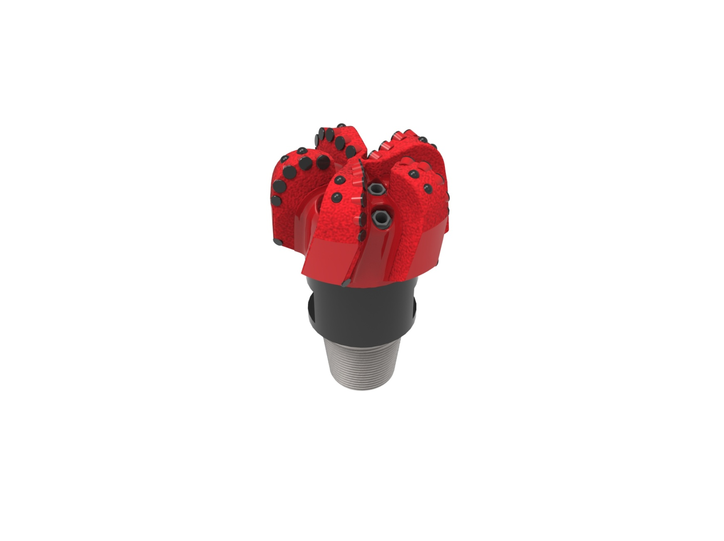
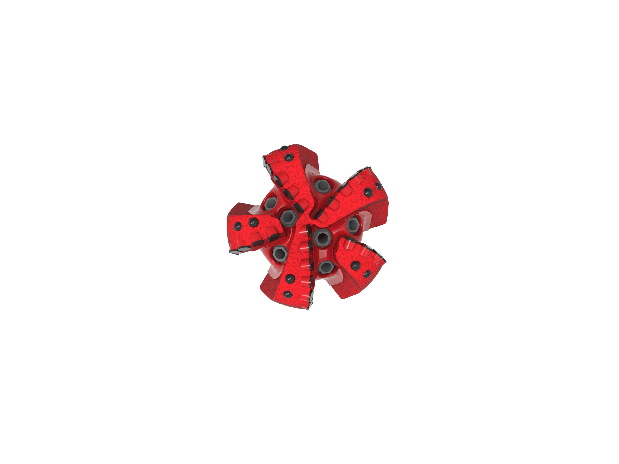

Drill Bit Specifications:
Cutter Size (Primary, Sec) | 11/16”,5/8”
Cutter Count (Total, Gage, Back Ream) | 36,5,5
Blade Count | 5
Gage Length (Inches) | 2.00
Nozzle Count (Primary, Sec.) | 5
Nozzle Series (Primary, Sec.) | 60
JSA (Sq. Inches) | 17.35
Max. TFA (Sq. Inches) | 2.60
Operating Parameters:
Max. Hydraulic Flow Rate (GPM) | 810
Max. Weight on Bit (1,000 Lbs.) | 60
Make-up Torque (ft/lbs) | 16,488
Nominal Dimensions:
Overall Length (Inches) | 13.80
Make Up Length (Inches) | 9.73
Bit Breaker | SKB-21010
Connection | Ø4-1/2" API Reg.
Approx. Weight (Lbs.) | 90

Tailor-Made Features:

- Premium grade cutters maximize ROP and Life
- 17mm Cutters
- Large open face volume assists cuttings removal
- Seven nozzles optimize blade cleaning and cuttings removal

517-SR7(K)(BR) Nomenclature Explained:

• | 5 | = | Number of Blades
• | 17 | = | Primary Cutter Size (17mm)
• | SR | = | Single Row of Cutters
• | 7 | = | Number of Nozzles
• | K | = | Bullets
• | BR+ | = | Back Reaming Cutters


